

CSE 3224

**INFORMATION SYSTEM DESIGN AND SOFTWARE ENGINEERING LAB**

Information Gathering and Interview

Submitted by

**Samin Shahriar Tokey** | 14-02-04-066

**Biozid Niloy** | 14-02-04-070

**Naimul Haque** | 14-02-04-080

**Sanaul miraj** | 14-01-04-131

Greener Earth

A website on Climate Change

Objectives:

The objective is to collect resourceful information about the climate and global warming, and present them in such a manner that any viewer of the website will get a clear idea of the matter.

Questionnaires and Interview pattern:

|  |  |  |  |
| --- | --- | --- | --- |
| **Greener Earth** | | | |
| **Author:**   * Naimul Haque * Samin Shahriar Tokey * Biozid Niloy * Sanaul Miraj | **Date:** 23/05/17 | **Time:** 10:00 am | **Duration:** 30min |
| **Participant:**   1. **Dr. Maksud Kamal**   ,Faculty of Earth and Environmental Science | | **Comments:**  The following interview has been conducted using a questionnaire to deduce the required information for developing the project. | |

Selection of Interview Personnel:

He is an expert in Environmental Science. He is also working on the Climate Science Research Bangladesh. He knows Why Some Conservatives Can’t Accept That Climate Change Is Real. He can tell what kind of contents in our website will make people feel that climate change is a real threat.

Total Interview procedure:

**Time:** 23rd May, 2017, 10:00 a.m.

**Place:** Faculty of Earth and Environmental Science, Dhaka University

**Personnel: Dr. Maksud Kamal**

**Questions:**

1. How much is the planet heating up?

Answer: 1.7 degrees over the past century and is actually a significant amount

1. How much trouble are we in?

Answer: For future generations, big trouble.

1. Is there anything we can do to save the?

Answer: Fly less, drive less, waste less.

1. What’s the worst-case scenario?

Answer: That is actually hard to say, which is one reason scientists are urging that emissions be cut; they want to limit the possibility of any worst-case scenario coming to pass. Perhaps the greatest fear is a collapse of food production, accompanied by escalating prices and mass starvation.

1. Why do people question climate change?

Answer: The most extreme version of climate denialism is to claim that scientists are engaged in a worldwide hoax to fool the public so that the government can gain greater control over people’s lives.

1. Is there any reason for hope?

Answer: Scientists have been warning since the 1980s that strong policies were needed to limit emissions. Those warnings were ignored, and greenhouse gases in the atmosphere have since built up to potentially dangerous levels. So the hour is late but there’s hope and mass people should be educated about the matter.

Data Collection through other sources:

We performed a survey

Link:

(<https://docs.google.com/forms/d/e/1FAIpQLSfzwZhMu8T3YG3PvIdJlA5TOVZRb3HJq2xs_hAaAeDBF2vgJQ/viewform>)

to know the view of a patient and their needs. The result analysis is given in the next pages:

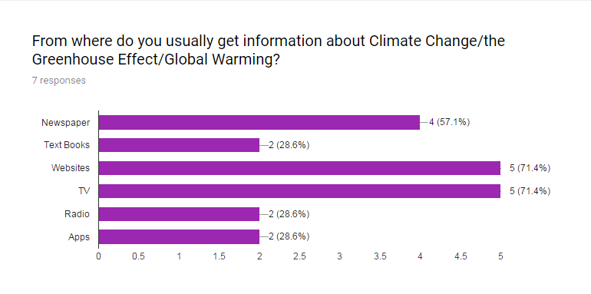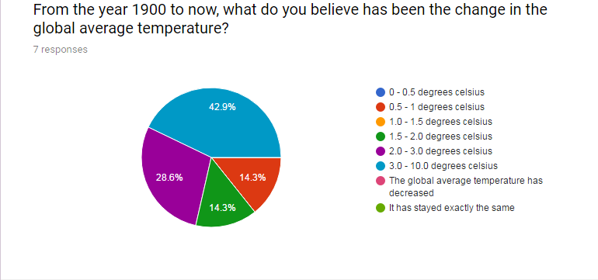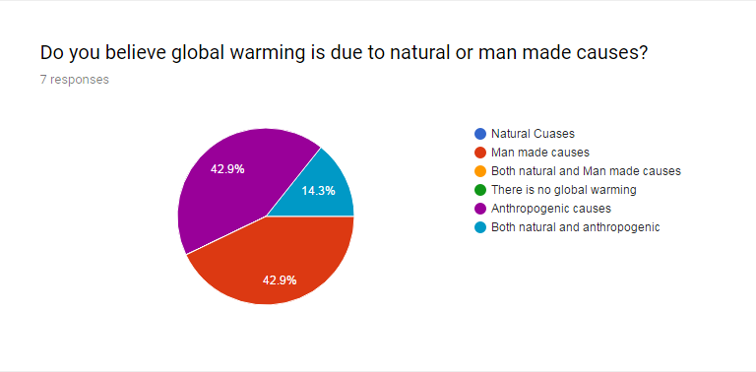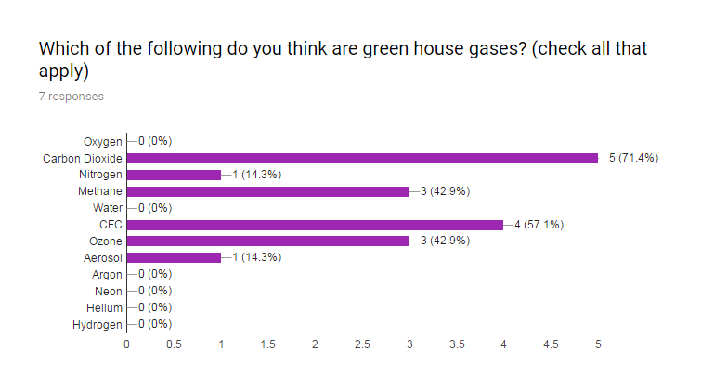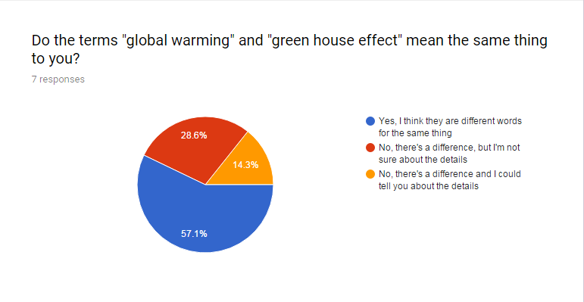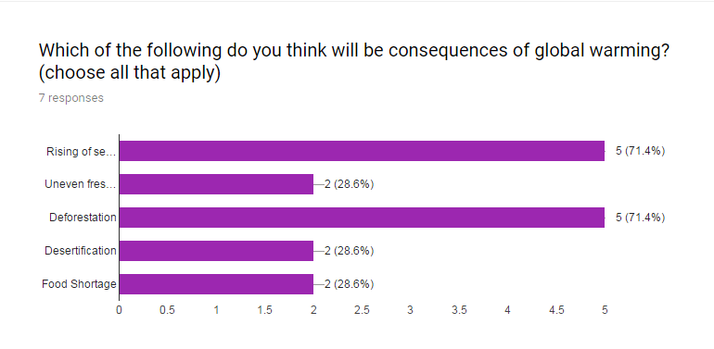

Revised requirements after collection of Data:

After collection of data we revised our software requirement and work. We must include the following features.

1. Scientific Blogs
2. Pages with climate records
3. Sections where people can send their ideas.

Conclusion:

After the interview and gathering information we have revised our design and development scheme for the system. Hopefully we can develop a useful, user friendly system that satisfies the requirements of our client.